GERMANY: ACCIDENT HOT SPOT MANAGEMENT

WHY ACCIDENT HOT SPOT MANAGEMENT?
Thinking that road traffic crashes are exclusively the result of driver fault is still quite popular – but it is also rather wrong: In many cases, poor road infrastructure has at least some influence on road safety. Identifying locations where road infrastructure systematically contributes to a high number of crashes (‘accident hot spots’), understanding the problems leading to those crashes, finding solutions to improve the situation and evaluating after some time if an accident hot spot has been worked on successfully – this is how accident hot spot management usually works. Accident hot spot processing is among the most effective measures road authorities can take to improve road safety and hence to undertake effective investments to support the national economy.

THE PROCESS
Identifying accident hot spots
The most important base for identifying accident hot spots is a reliable database. Ideally, the crash data should be georeferenced. This is very helpful to create maps using GIS, e.g. with different colors representing different types of crash (conflicts that lead to the crash). Further, a definition of ‘accident hot spot’ is required: It is usually based on a minimum number of crashes at a maximum length of a specific road section or at an intersection during a specific period of time. Crashes with serious injuries or fatalities may be weighted using an index based against crashes with minor physical injuries and crashes with material damage only. It can also make sense to analyze two different periods of time (e. g. three years for crashes with injuries/ fatalities and one year for all crashes or minor crashes only): Minor crashes happen more often. Systematic factors leading to low severity crashes may be different compared to serious crashes, so analyzing two different maps showing crashes with different severities may help, too.

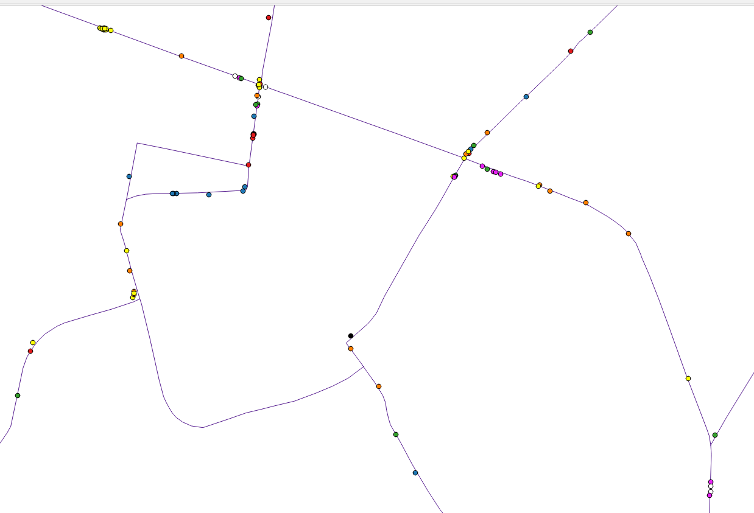
Source: Federal Highway Research Institute (BASt)

Analyzing accident hot spots
After an accident hot spot has been identified, the specific reasons for its existence will have to be identified. First, a table of all crashes should be created. It should contain at least year, month, day of the week, time, weather and light conditions, crash type, modes of transport involved in a crash and road conditions. Such a list may already give some indication of potential issues and countermeasures, e. g. if most crashes happen at night there may be some deficits regarding street lighting.
Second, a collision diagram schematically represents all crashes that have occurred at the hazardous location. The movements in the crash are graphically illustrated by arrows, specific signatures can show other systematic factors such as switched-off traffic lights, crashing against an obstacle, skidding etc. The travel direction of each vehicle and the exact location of each crash within the accident hot spot will have to be shown accurately in the diagram.
Such a diagram usually provides the most important information for further analysis: It shows the predominant crash types (and hence the predominant conflicts), the exact location where most crashes happen at the accident hot spot and further predominant similarities.

Source: Federal Highway Research Institute (BASt)

After formulating some hypotheses about potential crash and road environment issues, an on-site investigation will have to be carried out. Thus, hypotheses can be checked and more details can be added. The situation at the location should be examined using the results of the crash analysis as the starting point. The triggers for drivers' reactions and behavior patterns that may lead to a crash must be considered. Further investigations such as traffic counting and speed measurement can be carried out, too.

Countermeasures
Countermeasures should be identified with the aim of eliminating the main causes that were identified in the previous steps. Countermeasures should always solve the problem they are addressed to without creating some kind of “new” problem that was not there before, i.e. acting against one kind of crash should not generate another crash type or transfer the crashes to another place.
Further, countermeasures should be appropriate: For example, if redesigning the whole infrastructure at an accident hot spot with only minor crashes would create extraordinarily high costs, it should be checked if “light” (or low cost) measures like traffic signing, speed limits or stronger law enforcement could solve the problem, too. Similarly, if complex measures require a long-term process, it should also be checked if some “light” short-term measures could at least partially solve the problem.

Evaluation of countermeasures
Once countermeasures have been implemented at an accident hot spot the process is not yet completed: Although things might look easy in many cases, it might turn out after some time that the crashes are still present and different or further countermeasures will have to be taken. It is therefore very important to check after some time (usually after the period of time the identification of accident hot spots is also based on, but also earlier at regular intervals) if countermeasures led to a reduction in crashes or if they might have even led to a worsening of the situation.

FURTHER INFORMATION:
Further details can be found in the Merkblatt zur Oertlichen Unfalluntersuchung in Unfallkommissionen (in German, only published in print or via specific reader – see
https://www.fgsv-verlag.de/m-uko

Regarding the identification of accident hot spots, further details can be found in: Koerner et al., Examination and improvement of limit values for identification of black spots on the road network, DE, Bergisch Gladbach 2008 – see https://bast.opus.hbz-nrw.de/frontdoor/index/index/year/2018/docId/2054

